Guided Capstone Project Report

By: Nicole Quevillon

August 22, 2024

# Introduction

Big Mountain Resort has traditionally set its ticket pricing based on the market average ticket price. There is suspicion that this strategy is not fully capitalizing on the facilities offered by the resort. This project looked to explore how pricing could be adjusted to better reflect the facilities available at Big Mountain with the goal of increasing revenue from ticket sales.

Model overview

A model was built to predict ticket price given facilities offered by a resort such as vertical drop, number of runs, chairlifts, skiiable area etc. The model itself was informed by the ticket pricing and facility offerings of all other resorts across the US, so the model results reflect what ticket pricing would typically be expected in the US market given the facilities offered.

Two different types of models were tested, linear and random forest. The random forest had a slightly better model fit, so that is what is used for the final model.

Data Overview

After cleaning, the resort data used for this model included information on 277 resorts across the US. These records were assessed and cleaned where there were missing values or obvious typos.

# Findings

Resort facilities that impact pricing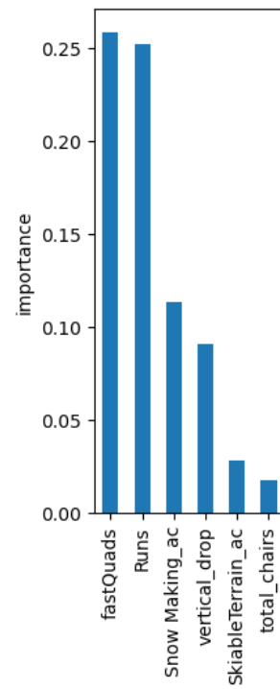

We first looked to identify which facilities were the strongest predictors of ticket price using an extensive list of facilities available at resorts across the nation. The facilities that were the most important predictors of ticket price were the number of fastQuads, the total number of runs, the amount of snow making area, and the highest vertical drop at a resort.

Model results for Big Mountain

Big Mountain currently charges $81 per Adult Weekend ticket. With the resort’s current facilities, the model predicts that Big Mountain could be charging around $95 per ticket. This increase is reflective of the fact that Big Mountain is well above average in many of the facility offerings that were identified as important such as skiable terrain, number of runs, and area covered by snow making equipment.

Big Mountain facility scenarios

Big Mountain’s executive team is also considering making some changes to the facilities offered. The model was used to assess the potential ticket price impact from these changes.

**Scenario 1: Close up to 10 of the least used runs**

There is no negative impact on pricing of closing one run. Closing 2-5 runs causes a moderate price decrease, so the cost savings of closing these runs would have to be evaluated against the revenue reduction from lower ticket prices. Closing six or more runs would result in a significant price decrease and is not recommended.

**Scenario 2: Add a run that adds 150m to the vertical drop and requires a new chairlift**

This is expected to add $1.99 to the ticket price which amounts to $3,474,638 in additional revenue per season. The cost of the new chairlift should be evaluated against this revenue.

**Scenario 3: Scenario 2 plus an addition of 2 acres of snow making**

There is no change to the ticket price vs Scenario 2 since the increase in snow making acreage is so small. This scenario is not recommended.

**Scenario 4: Increasing the longest run by 0.2 miles and add 4 acres of snow making**

There was no change in the expected ticket price. This scenario is not recommended.

# Conclusion

Based on the pricing of other ski resorts across the country, Big Mountain is currently charging below the expected price for tickets. With the resort’s current facilities, Big Mountain could be charging around $95 per ticket versus the $81 that is the current price.

Before moving ahead with this recommended price increase, it is important that the Big Mountain team evaluates this pricing with more of a local focus to ensure the conclusion we have drawn from the national level can be safely applied to the Montana market. This study certainly supports the idea that there is room for an increase in ticket price, but the actual extent of that increase should be further tested before it is committed to.

In terms of the facility adjustments being considered, closing up to 6 runs and adding a new run that increases vertical drop are options worth further exploration.